What factors explain international leadership in the nanotechnology sector? In your answer, describe the role of the development of new organisational forms and technologies?

Introduction
Nanotechnology is existent since the 4th century but has gained momentum in recent times (Percenta Nanotechnology, 2016). This has drawn the attention of people from different walks of life from across the world. During the period between years 2017 and 2024 this nanotechnology industry is expected to experience a growth of 17% compounded annual growth rate (CAGR) thereby depicting the scale of escalation it is bound to achieve (Research and Markets, 2018). Nanotechnology today has entered multiple industries ranging from automobiles to healthcare and from education to agriculture to name a few from its emergence in the glass industry in the 4th century. However, irrespective of nanotechnology being age-old technology its applications are still evolving thus making it fascinating to study.
The primary intention of this study is to critically examine the various factors that result in international leadership in the nanotechnology sector. Some of the factors discussed are the role of government, new technologies, new organisational forms and investments in research and development. The study begins with a determination of the concept of nanotechnology and then discusses the TEN model in relation to nanotechnology. Further the factors are analysed and finally, the trend for the future is anticipated.

Concept of Nanotechnology
Nanotechnology is management and making of materials that are of very small size and measured on a nanoscale. This scale has a reading that ranges between 1 nanometer to 100 (National Research Council et al., 2002). It is considered to be an intricate technology that incorporates various disciplines of knowledge primarily science. It also comprises of industries related to the same. Owing to the basic fact that nanotechnology is integrative comprising of multiple disciplines, it is considered to bring about revolutionary changes in varied industries and sectors. Thus, nanotechnology is expected to result in industrial uprisings thereby endowing companies and nations with opportunities to derive benefits from.
It is the lucrativeness of this technology that companies and nations are motivated to invest humongous amounts in research and development thus supporting the growth of this technology (Peris-Ortiz, et al., 2016). These investments in research and development of nanotechnology are not only supported by developed nations but emerging nations and other developing ones are also equally showing interests in the same. These nations like China are aggressively investing in nanotechnology to gain a competitive edge in the global arena and at the same time rouse its pace of development (Tang & Shapira, 2011). The ranking of the top 10 nations which included both developed and emerging nations is provided in the table below:
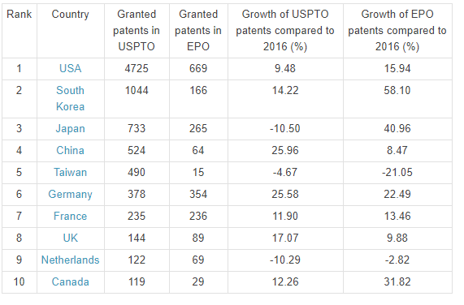
Figure 1 Top 10 countries in the number of nanotechnologies granted patents published by USPTO in the year 2017
Source: (StatNano.com, 2018)

The TEN Framework and Nanotechnology
The TEN framework which is the abbreviation of Techno-Economic Network framework which is used to comprehend the process espoused for technology transfer. It is based on three primary poles namely, scientific, technical and marketing pole as depicted in the figure below:
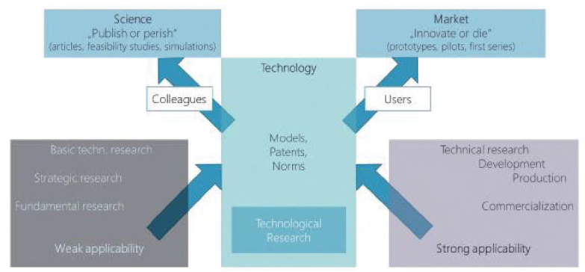
Figure 2 Techno-Economic Framework
Source: (Costa, et al., 2018)
This model is considered significant as it assists in the determination of aspects and phases of transfer of technology. The model helps in examining innovation within a sector in a comprehensive manner (Islam & Ozcan, 2013). It also helps in determining the various stakeholders who are being impacted by technology transfer. However, as per Kumar (2014), nanotechnology is still in the phase of evolution as it is an embryonic stage with regards to research and development as well as innovation. It is thus a part of the emergent archetype of the techno-economic framework. In the same study Kumar (2014) further denoted that nanotechnology is a more disruptive technology in nature as compared to those considered as sustaining. By disruptive technology, it is meant that the users of this technology need to abide by changes within their behaviour in order to abide by such technologies whose development is dependent on discontinuous innovations.
In the study by Islam & Ozcan (2017) the application of the above model with respect to different nations was outlined. In accordance with this study, the developed nation like the United States withholds its spot within TEN model poles namely science and technology. This endows the nation with not only a powerful position within the global arena but also gives it a competitive edge over others. The study further elaborating about other nation's position stated that in the case of Japan, this competitive edge has been compromised over the years as the nation lost its power in proficiencies related to nanotechnology. Nations like South Korea and China from the Asia-Pacific region are enhancing their competitive advantages in nanotechnology and thus emerging as strong competitors for the United States. All the four nations mentioned in this study by Islam & Ozcan (2017) also hold a position among the top 10 nations as shown in figure 1. From figure 1, it is clearly evident that the US has a dominant position followed by South Korea and then Japan and China respectively.

Factors explaining leadership in Nanotechnology Sector
In this section, the primary factor that has supported nations to gain a leadership position within the nanotechnology sector is are being examined.

New Technologies
The new technologies and their emergence have been playing a strong role in determining the leadership of nations in the nanotechnology sector. The nations which were once claimed as underdeveloped or developing have found a position with the list of most significant nations involved in nanotechnology. This has been determined by Niosi & Reid (2007) who in their study notified that nations like India, China and Brazil have been dedicatedly investing in the sphere of biotechnology and nanotechnology. Though biotechnology originated in the United States but yet it has been widely accepted by these nations namely, China, India and Brazil. In China this new technology that is biotechnology motivated firms to pursue research and development thereby making investments at both private and public level. The positive benefits derived through biotechnology by China motivated the nation to derive benefits from nanotechnology too. The nation attracted foreign direct investments (FDI) in the sphere of technology especially new technologies and thus taking measures for the achievement of leadership within the nanotechnology sector. Nanotechnology has also been applied to the biotech industry as nano-biotech thus creating opportunities for nations like India to excel in. For example, both biotechnology and nanotechnology has been adopted in India for the economic development of the marginal farmers whereas for the USA the focus of using these technologies are mainly in areas of health of human beings and environmental effects (Beumer & Bhattacharya, 2013).
Another prominent technology that has supported nations in gaining leadership in nanotechnology is the internet. This technology has supported widespread use fo internet by the development of multiple applications which has supported the growth and development of industries ranging from military to information technology (IT). Development of mechanisms related to surveillance, a collection of data and devices for tracking. These have changed the overall approach towards logistics involved in the movement of medicines and the way the military operates. This has endowed the US with a leadership position by strengthening its military power using nanotechnology (Miller & Kearnes, 2013). Nations like China are striving to gain a leadership position. Nations like the United Kingdom (UK) and China have followed suit. Even other nations namely, Russia, Israel, Sweden and India are also investing in nanotechnology for military upgradations thus steeping towards gaining leadership positions.
With the development of information technology, nanotechnology has also supported the same in aspects like radio-frequency identification (RFID). This technology has not only supported tracking of materials and/or products but also human beings. The use of this technology for human beings was first approved by the United States Food and Drug Administration thus making the nation a leader in it (Miller & Kearnes, 2013).

Government Policies
The government of various nations are also actively participating in ensuring that the nation as a whole derives benefit through nanotechnology. In order to support the same, these nations have designed several activities which have supported them to gain a leadership position. For example, in the United States, the federal government in the year 2001 designed the USA National Nanotechnology Initiative (NNI). This initiative was a part of the government's dedication towards supporting the technology thus assisting the nation to gain a leadership position. The NNI is being supervised by of National Science and Technology Council. The US government has undergone an investment of approximately 15.6 billion USD between the timeframe of 11 years commencing from 2001 to 2012. The budget for the year 2013, for investments in nanotechnology by the US government was approximately 1.767 billion USD (Ezema, et al., 2014).
Even the government of Asian nations like Japan and China have undertaken strategic efforts to support widespread growth of nanotechnology thus ensuring that these nations are ranked among the international leaders in the nanotechnology sector list. In both these nations, that are Japan and China nanotechnology efforts are supported by the Ministry of Science and Technology of respective nations (Ezema, et al., 2014; Ahmadi, 2017). For Japan, the primary focus areas through government investments in nanotechnology are the escalation of industries namely nanomaterial electronics, nanodevices and nano-biomaterials. It is owing to the dedicated efforts of the government of these nations that they are giving tuff competition to the USA. It is evident from the fact that since 2004 the publications made in the sphere of nanotechnology by China are much higher than those done in the USA (Ahmadi, 2017). The Chinese government has designed integrated plans wherein the national government agencies and the state one’s work in a collaborative manner thus supporting small and medium scale (SMEs) companies thereby facilitating holistic development in the area of nanotechnology (Ezema, et al., 2014).

New Organisational Forms
With nanotechnology, deep-seated changes are being experienced within organisational systems and forms. These changes, in turn, support the development of nanotechnology, thus forming a cycle. These changes within the organisation are evident through the generation of novel products, processes and related systems. With the convergence of innovation in nanotechnology, knowledge is being generated and transferred across the organisation thereby bringing about changes in the same (Guzmán, et al., 2018). In this mechanism of emergence of new organisational forms, information technology has played an overriding role thus helping organisations to resort to intricate strategies to achieve the desired vision. Companies operating within general purpose technology (GPT) based on nanotechnology are also resulting in sudden changes within the social order which has revitalised its growth (Shea, et al., 2011). This is basically true in the case of transformation GPT. The outcomes are in form of innovative processes, organisational forms and products. The hybrid
A revolution with the organisational forms is also being acknowledged which has been shaping the leadership in nanotechnology. This is particularly evident in the case of China where innovative organisational forms are emerging that are based on science. Thus, contemporary organisations are experiencing an amalgamation between academicians and managers rather than both competing against each other (Ahmadi & Kuliah, 2017). Applied research is considered the most important aspect of science in recent times. Even organisations are investing religiously in research and developmental activities by setting up research laboratories based on science. This has been one of the factors that have supported China to move ahead in nanotechnology industry at an international level.
In the case of developed nations primarily comparing the US and the European Union (EU) nations, it can be determined that the organisational forms in the US are based on the principles of adversarial approach (Beumer & Bhattacharya, 2013). This particularly has an impact on decision making where ultimate decisions are shaped based on discussions and arguments. In the EU a more consensual approach to decision making is resorted to (Beumer & Bhattacharya, 2013). However, it has been observed that the EU organisational forms are more subjected to corruption which has resulted in their downfall in the high technology arena especially nanotechnology. But the USA has been successful in not only adopting nanotechnology but also benefitting from the same. This has been one of the factors behind the US raking at the top position within the lost of nations having nanotechnologies granted patents whereas only two EU nations namely, France and Germany have been able to position themselves in the same.

Research and Development
Different nations have made different research publications in the field of nanotechnology as can be seen in the figure below:
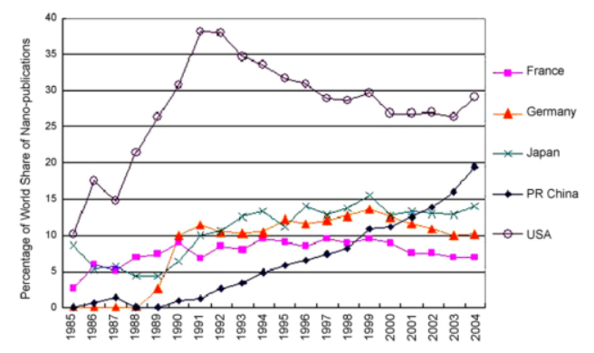
Figure 3 Percentage of world share in Nano publications
Source: (Ahmadi & Kuliah, 2017)
Funding plays a prominent role in ensuring effective research and development activities are pursued which is also the fact for nanotechnology. Funds are being generated and transferred to companies to pursue such activities. In the year 2018, a series of companies are anticipated to receive funds from multiple sources thus boosting their research and developmental activities in nanotechnology. Below is the list of companies that are expected to draw interests of investors:
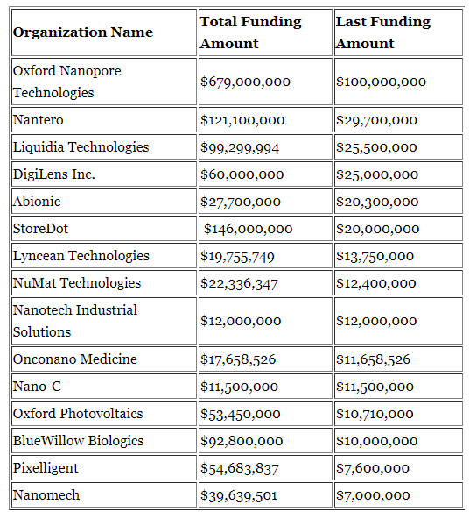
Figure 4 15 Nanotechnology Companies Getting Funding in 2018
Source: (Nanalyze, 2018)
Most of the companies that had made to the list above are from the US thus depicting one of the reasons behind the US being at the top position in nanotechnology.
Not only does the government it is the private companies also from the US who have supported the nation to gain and retain its position within the top 10 nations for nanotechnologies granted patents. Some of the companies especially those involved in computers and complimentary industries to it namely Hewlett Packard, Motorola, IBM, and Intel have been taking multiple efforts to support the growth of nanotechnology (Ezema, et al., 2014). In pursuit of the same, these companies are working in partnership with the universities. Nanotechnology is taken up by a large number of companies from different areas of Japan thus supporting the nation to gain a competitive edge over others. These companies have assisted the holistic economic development of the nation by not only generating employment opportunities but also regional development. The outcome has been that the USA has sustained its position as a developed nation along with being a dominant economic power in the global platform. However, nations like India are gearing up and the private companies from the nation are leaving no stone unturned for deriving benefits from nanotechnology. Some of the companies taking dedicated efforts in research and development through funding nanotechnology are Tata Steel, Tata Chemicals, Mahindra and Mahindra, Nicholas, Piramal, Reliance, Tata Chemicals and Intel (Beumer & Bhattacharya, 2013).
The significance of nanotechnology is also realised by non-government organisations (NGO) and they have also started investing in research and development in nanotechnology. Once such NGO has been The Energy and Resources Institute (TERI) which has been making research in the field of governance, toxicology, and capacity building based on funds received from International Development Research Centre (Beumer & Bhattacharya, 2013).

The Trend and Future Anticipations
Nanotechnology is one arena that has brought about revolutionary changes in each and every sphere and the nations are not leaving any stone unturned for availing benefits from the same. Nanotechnology is set to enter the 5th phase of revolution related to technology. Considering the past, it has been identified that the United States has been undoubtedly the leader in nanotechnology by undertaking holistic development and the various factors supporting its development. All the four technology revolutions with regards to nanotechnology ranging from organisational forms to investments and from government assistance to new technologies have proved to be conducive for the United States. It has also been observed that with US other nations also have made dedicated efforts for developing themselves and keep pace with the technology revolution in each phase thereby trying to surpass the US. However, irrespective of such efforts through the nations are progressing in nanotechnology but yet it has been anticipated that the US would continue to rule in this industry. It is mainly because the approach towards nanotechnology in the US is holistic and comprehensive rather than being focused on specific areas ( McDermott Will & Emery., 2012). This has been done by the US by resorting to a diversification strategy wherein multiple sectors are being influenced. The nation has been setting standards for research and development in nanotechnology for the world to follow. Within the US itself, multiple regions are emerging cynosure for nanotechnology in recent times. These regions are California, New York, Massachusetts, and Texas. Hence, US is leading by examples. Thus, it can be safely said that the US would continue being the epicentre for nanotechnology development.
Nevertheless, with the US, another nation that is progressing through aggressive moves within the nanotechnology industry is China (Ahmadi, 2017). For China investments in nanotechnology has been adopted as a strategic approach towards development by the nation as a whole. It has been the government of the nation that has been primarily responsible for widespread progress of nanotechnology within China. The outcome of such investments is that China is putting forward stringent competitive pressure on the US. The growth in nanotechnology experienced by China is unprecedented and given the way it has been progressing, there are bright chances of this nation to surpass the US in times to come.
To conclude it can be stated that nanotechnology is indispensable for nations seeking to develop sustainably in the long run. The technology has marked a presence in all the aspects of human lives and thus cannot be replaced. The benefits derived from this technology is much higher than the challenges owing to which nations are making strategic efforts to abide by the same.

References
McDermott Will & Emery., 2012. Nanotechnology -- Who will be the leaders in the fifth technology revolution?, Chicago: McDermott Will & Emery..
Ahmadi, K., 2017. Nanotechnology in China: Analysis on International Competitiveness. [Online]
Available at: https://www.linkedin.com/pulse/nanotechnology-china-analysis-international-kiki-ahmadi
[Accessed 4 Dec 2018].
Ahmadi, K. & Kuliah, C., 2017. International Competitiveness in Nanotechnology. [Online]
Available at: https://kikiahmadi.com/2017/03/14/international-competitiveness-in-nanotechnology/
[Accessed 4 Dec 2018].
Beumer, K. & Bhattacharya, S., 2013. Emerging technologies in India: Developments, debates and silences about nanotechnology. Science and Public Policy, 40(5), pp. 628-643.
Costa, C., Au-Yong-Oliveira, M. & Amorim, M., 2018. ECIE 2018 13th European Conference on Innovation and Entrepreneurship. Portugal: Academic Conferences and publishing limited..
Ezema, I., Ogbobe, P. & Omah, A., 2014. Initiatives and strategies for development of nanotechnology in nations: a lesson for Africa and other least developed countries. Nanoscale research letters, 9(1), p. 133.
Guzmán, A., Romero, E. & Grossman, F., 2018. Convergence of innovation in the nanotechnology. Contaduría y Administración, 63(1), pp. 37-38..
Islam, N. & Ozcan, S., 2013. Nanotechnology innovation system: An empirical analysis of the emerging actors and collaborative networks. IEEE Transactions on Engineering Management, 60(4), pp. 687-703..
Islam, N. & Ozcan, S., 2017. The management of nanotechnology: analysis of technology linkages and the regional nanotechnology competencies. Strategy and Policy Decisions in R&D Management, 47(1), pp. 111-126.
Kumar, A., 2014. Nanotechnology Development in India: An Overview. New Delhi: Research and Information System for Developing Countries..
Miller, G. & Kearnes, M., 2013. Nanotechnology, Ubiquitous Computing and The Internet of Things: Challenges to Rights to Privacy and Data Protection Challenges to Rights to Privacy and Data Protection, Strasbourg: Council of Europe.
Nanalyze, 2018. 15 Nanotechnology Companies Getting Funding in 2018. [Online]
Available at: https://www.nanalyze.com/2018/06/15-nanotechnology-companies-funding-2018/
[Accessed 4 Dec 2018].
National Research Council, Division on Engineering and Physical Sciences & Committee for the Review of the National Nanotechnology Initiative, 2002. Small Wonders, Endless Frontiers: A Review of the National Nanotechnology Initiative. Washinton DC: National Academies Press.
Niosi, J. & Reid, S., 2007. Biotechnology and nanotechnology: science-based enabling technologies as windows of opportunity for LDCs?.. World Development, 35(3), pp. 426-438..
Percenta Nanotechnology, 2016. Timeline. [Online]
Available at: https://percenta-nanoproducts.com/timeline/
[Accessed 3 Dec 2018].
Peris-Ortiz, M., Ferreira, J., Farinha, L. & Fernandes, N., 2016. Multiple Helix Ecosystems for Sustainable Competitiveness. Berlin : Springer.
Research and Markets, 2018. Global Nanotechnology Market Outlook 2017-2024 with Profiles of Key Players - Altair, Nanophase Tech, Nanosys. [Online]
Available at: https://www.prnewswire.com/news-releases/global-nanotechnology-market-outlook-2017-2024-with-profiles-of-key-players---altair-nanophase-tech-nanosys-300582991.html
[Accessed 3 Dec 2018].
Shea, C., Grinde, R. & Elmslie, B., 2011. Nanotechnology as general-purpose technology: empirical evidence and implications. Technology Analysis & Strategic Management, 23(2), pp. 175-192..
StatNano.com, 2018. Top Ten Countries in Nanotechnology Patents in 2017. [Online]
Available at: https://statnano.com/news/62082
[Accessed 3 Dec 2018].
Tang, L. & Shapira, P., 2011. China–US scientific collaboration in nanotechnology: patterns and dynamics. Scientometrics, 88(1), pp. 1-16..

